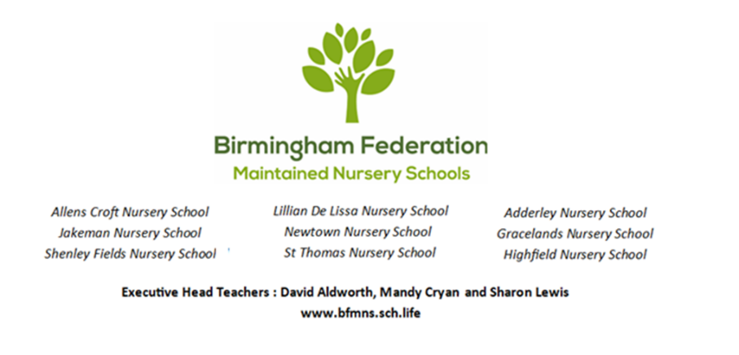

Governors' Annual Report 2025–26
Celebrating Inclusion
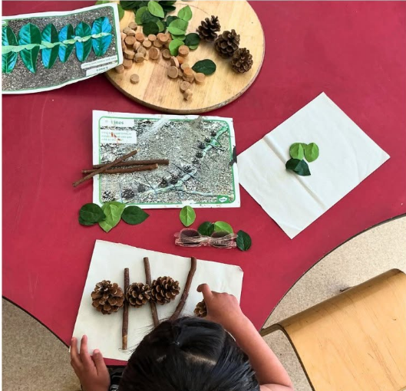

Celebrating Inclusion Across Our Federation

Every Child. Every Family. Every Community.
Inclusion is not a programme or a single initiative. It is the foundation upon which every School that forms part of the Birmingham Federation of Maintained Nursery School is built. It shapes how we welcome children and families, how we design our learning environments, how we develop our curriculum and, most importantly, how we see every child—as capable, curious and full of potential.
Across our Federation, inclusion means recognising that every child arrives with their own experiences, interests, culture, language and way of learning. It means creating places where every child feels they belong from their very first day, where differences are celebrated rather than simply accommodated, and where children are encouraged to become confident, resilient and independent learners. Whether a child is taking their very first steps into nursery, learning English as an additional language, requiring additional support to communicate, or demonstrating exceptional curiosity and creativity, our schools are committed to ensuring that every child is known, understood and enabled to flourish.
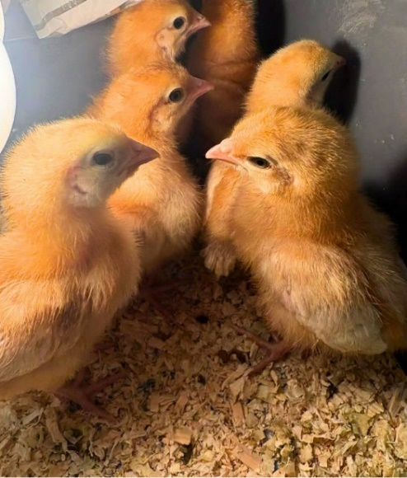
This commitment is reflected in every aspect of our work. Our practitioners create rich learning environments that inspire exploration and imagination. They carefully observe children's fascinations, adapting experiences to build upon what children already know and can do. Families are recognised as children's first and most important educators, and strong partnerships between home and nursery ensure that learning continues beyond the classroom. Across all nine schools, highly skilled staff work collaboratively with health professionals, therapists, specialist teachers and community organisations so that children receive the right support, at the right time, in the right way.
Inclusion also means learning from one another. One of the greatest strengths of our Federation is the way our schools work together, sharing expertise, reflecting on practice and continually striving to improve outcomes for children. Headteachers, teachers, SENDCOs, curriculum leaders and practitioners meet regularly through Federation networks to develop new ideas, share research and strengthen professional practice. Governors play an equally important role, visiting schools throughout the year to celebrate success, ask challenging questions and ensure that every decision remains focused on improving children's experiences and opportunities.
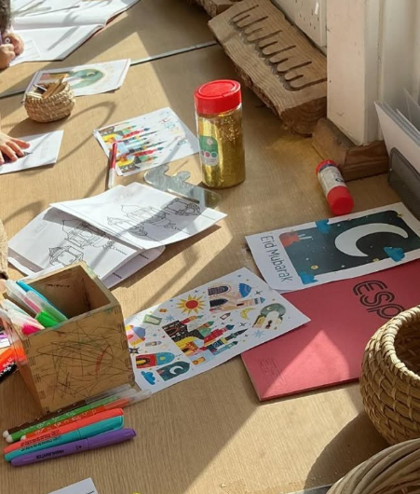
This year's report highlights many examples of inclusion in action. Across the Federation we have continued to develop outstanding provision for our youngest children, expanded opportunities for children with additional needs, strengthened children's communication and language, enriched outdoor learning environments and invested in professional learning for staff. Schools have continued to build strong relationships with families and communities while creating imaginative spaces that inspire curiosity, creativity and joyful learning. Although each nursery has its own distinctive identity, every school shares the same ambition: that every child should experience a sense of belonging, develop confidence in themselves and leave nursery ready for the next stage of their learning journey.
The pages that follow celebrate the unique contribution of each of our nine nursery schools in 2025/26. Together they demonstrate that inclusion does not look exactly the same in every community—and nor should it. Each school responds to the needs, strengths and aspirations of the families it serves while remaining united by a common purpose: providing exceptional early childhood education where every child can thrive.

Message from the Chair of Governors
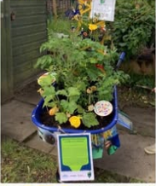
Dear Parents, Carers, Colleagues and Friends,
It gives me enormous pleasure to introduce this year's Annual Report on behalf of the Governing Board of the Birmingham Federation of Maintained Nursery Schools.
Every year, as Governors, we have the privilege of visiting our schools, meeting children, talking with families and staff, and seeing first-hand the remarkable work taking place across our Federation. While each of our nine nursery schools has its own unique character and serves a different community, they are united by a common belief: that every child deserves to feel valued, included, respected and able to flourish.
For that reason, our theme for this year's report is "Celebrating Inclusion."
Inclusion is much more than ensuring every child has a place in our schools. It is about creating communities where every child belongs, where differences are recognised as strengths, and where each individual is supported to develop confidence, curiosity and a love of learning. It is about understanding that children thrive when families are welcomed as partners, when skilled professionals work collaboratively, and when learning environments are carefully designed to enable every child to succeed.
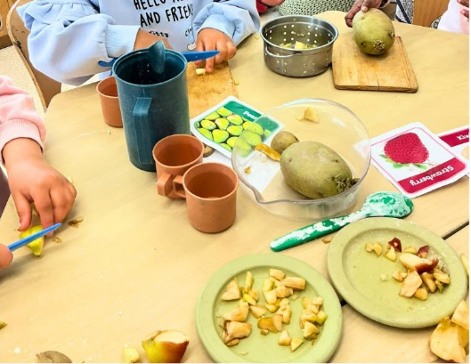
This commitment to inclusion has been evident throughout the Federation during the past year.
Across our schools we have continued to expand high-quality provision for under twos, enabling more children to benefit from exceptional early education at the very beginning of their learning journey. We have strengthened our support for children with Special Educational Needs and Disabilities through highly skilled practitioners, collaborative SEND networks and increasingly inclusive learning environments.
Our curriculum leaders, Deputy Headteachers and SENDCOs have continued to work together across the Federation, sharing expertise and ensuring that every school benefits from collective professional knowledge and experience. Governors have also continued to play an active role through regular monitoring visits, providing both support and constructive challenge as we strive for continuous improvement.
There have been many other achievements to celebrate including positive external recognition of the quality of education provided across a number of our schools. New childcare provision has become firmly established in several schools, innovative outdoor learning environments have continued to develop, attendance has improved across many settings, and schools have strengthened partnerships with families and local communities. Alongside this, staff have continued to strengthen curriculum development through research-informed practice and ongoing professional learning and continued to lead the way in developing outstanding inclusive practice. These achievements reflect the ambition, creativity and resilience of everyone who works within our Federation.
What continues to impress me most, however, is not simply the breadth of these developments, but the culture that underpins them. During governor visits we consistently see children who are confident, curious and deeply engaged in their learning. We see practitioners who know every child as an individual and respond thoughtfully to their interests, strengths and needs. We see environments that encourage exploration, independence and joyful discovery. Most importantly, we see schools where relationships matter and where every child is known, valued and encouraged to succeed. These qualities are reflected throughout the governor monitoring reports included within this year's evidence base.
This report celebrates just a small selection of the many successes achieved during 2025–26. Each school's contribution tells its own story of innovation, partnership and inclusion, but together they demonstrate the extraordinary impact that can be achieved when schools collaborate as one Federation while remaining deeply connected to the communities they serve.
On behalf of the Governing Board, I would like to thank every member of staff, every volunteer, every Governor and every family for the part you have played this year. Your commitment, professionalism and unwavering belief in children make our Federation an exceptional place to learn and grow.
Finally, to those children who will shortly begin the next stage of their educational journey, we wish you every success and happiness in your new schools. We hope you leave us with wonderful memories, growing confidence and a lifelong love of learning. To those returning in September, we look forward to another exciting year of exploration, discovery and achievement together.
Thank you for your continued support of the Birmingham Federation of Maintained Nursery Schools.
With best wishes,
Sean Delaney
Chair of Governors

Federation Highlights 2025–26


Working Together to Give Every Child the Best Start
The Birmingham Federation of Maintained Nursery Schools is more than a group of nine exceptional nursery schools. It is a community of educators, leaders, Governors and families working together to ensure that every child receives the very best start in life. During 2025–26, our shared commitment to collaboration, innovation and inclusion continued to strengthen opportunities for children across Birmingham.

Investing in Our Youngest Learners
This year saw continued investment in high-quality provision for under twos across the Federation. Schools have continued to develop welcoming, age-appropriate environments where secure relationships, curiosity and early communication are nurtured from the very beginning. These developments ensure that families can access exceptional early education from the earliest stages of childhood, helping children develop confidence, independence and a lifelong love of learning.

Championing Inclusion
Every school within the Federation has continued to strengthen its inclusive practice. Dedicated SENDCOs, highly skilled practitioners and close partnerships with specialist services have ensured that children with additional needs receive personalised support while remaining fully included in nursery life. Across the Federation, staff have continued to develop expertise in communication and language, sensory regulation, emotional wellbeing and inclusive curriculum design so that every child can participate, belong and flourish.

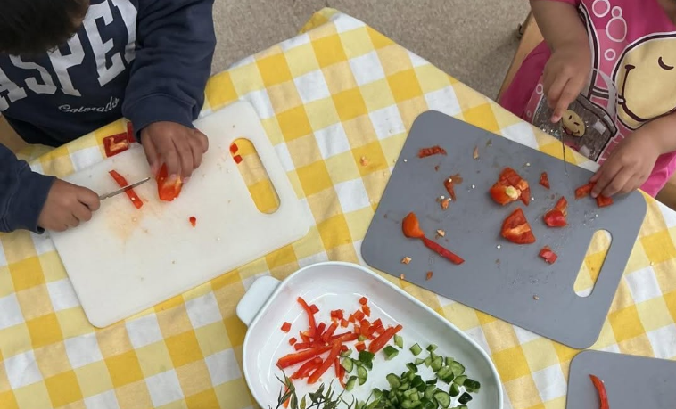

Learning Through Collaboration
One of the Federation's greatest strengths continues to be its culture of professional collaboration. Throughout the year, Headteachers, teachers, SENDCOs and curriculum leaders have worked together through Federation networks to share research, reflect on practice and develop innovative approaches to teaching and learning. This collaborative model ensures that expertise developed in one school benefits children across all nine nurseries and supports continuous improvement throughout the Federation.

Rich Environments for Curious Minds
Across the Federation, learning environments have continued to evolve in response to children's interests and needs. New outdoor learning spaces, creative studios, investigation areas, sensory environments and imaginative role-play spaces have encouraged children to explore, experiment and develop independence through play. These carefully designed environments reflect our belief that children's surroundings are a powerful part of the curriculum, inspiring creativity, problem-solving and joyful learning every day.

Working in Partnership with Families
Families remain at the heart of everything we do. Throughout the year, schools have continued to develop opportunities for parents and carers to become active partners in their children's learning through workshops, family events, coffee mornings, lending libraries, shared celebrations and regular communication. By working together, schools and families have created strong foundations that support children's wellbeing, confidence and development both at nursery and at home.

Celebrating Success
There has been much to celebrate across the Federation during 2025–26. Schools have continued to receive positive external recognition for the quality of their provision, strengthened their curriculum offer, invested in staff development and expanded opportunities for children and families. Governors have seen first-hand the impact of this work during their visits, consistently observing happy, confident children, highly skilled practitioners and learning environments where curiosity, inclusion and belonging are evident in every interaction.

Together, We Are Stronger
While every nursery school has its own unique character, the Federation's greatest achievement continues to be the way it works together. By sharing expertise, supporting one another and maintaining a relentless focus on children's wellbeing and learning, our schools continue to demonstrate the power of collaboration. As Governors, we are immensely proud of the dedication, professionalism and compassion shown by every member of staff, and we thank them for the extraordinary difference they make to the lives of Birmingham's youngest children every single day.

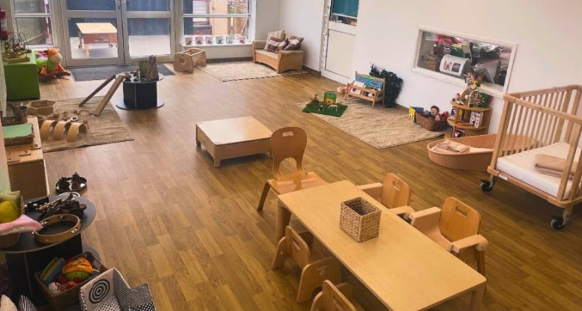

Adderley Nursery School

Growing Together Through Curiosity and Belonging
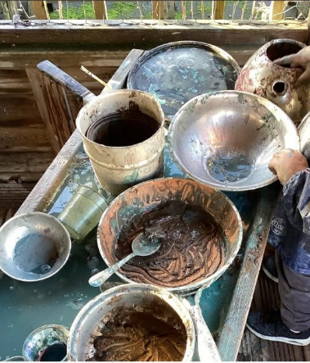
At Adderley Nursery School, inclusion begins with relationships. Staff carefully observe how friendships develop and use this understanding to create experiences that help every child feel confident, valued and able to participate.
This year, children have become fascinated by the changing natural environment, exploring flowers, wildlife and the seasons through imaginative outdoor learning. Using simple viewing tubes as "telescopes", children investigated perspective, asked thoughtful questions and developed their scientific thinking through play. These shared experiences have strengthened children's communication, collaboration and curiosity while celebrating every child's unique way of learning.
The nursery's welcoming ethos extends well beyond the classroom. Serving a richly diverse community, Adderley celebrates the many languages and cultures represented within the school while building strong partnerships with families and local organisations.
Governors are particularly proud of the calm, nurturing atmosphere that enables every child to flourish, supported by highly skilled practitioners who continually develop their expertise through professional learning and reflective practice.

Allens Croft Nursery School


Curiosity Starts with the Littlest Learners
At Allens Croft Nursery School, every aspect of the curriculum is designed to celebrate childhood and ensure that every child feels a genuine sense of belonging. This year has seen the continued development of Little Nursery, providing a carefully planned environment where two-year-olds build secure relationships, confidence and independence through play. Across both Little Nursery and Big Nursery, children have immersed themselves in high-quality stories, imaginative role play and enquiry-led learning.
Governors particularly enjoyed seeing children's interests transformed into meaningful experiences, from the popular Allens Croft Café, where children enthusiastically wrote menus, took customer orders and explored new vocabulary through imaginative play, to investigations inspired by maps, roads and insects. Throughout the nursery, practitioners carefully follow children's fascinations, ensuring that learning remains engaging, purposeful and rooted in children's own ideas.
Inclusion continues to define life at Allens Croft. The nursery's integrated Resource Base, Discovery Team and highly regarded SEND provision ensure that every child can access the full curriculum alongside their peers. Daily WellComm interventions, Attention Autism approaches, sensory circuits and strong partnerships with families help children develop communication, confidence and emotional wellbeing from the very beginning of their learning journey. The school's commitment to children's rights, wellbeing and healthy lifestyles is reflected through its Rights Respecting School work, My Happy Mind, Startwell, family workshops and thriving lending library.
Governors are immensely proud of the outstanding practice seen throughout the nursery and of a staff team whose warmth, expertise and ambition ensure that every child is encouraged to flourish.

Gracelands Nursery School

A Place Where Creativity and Confidence Flourish
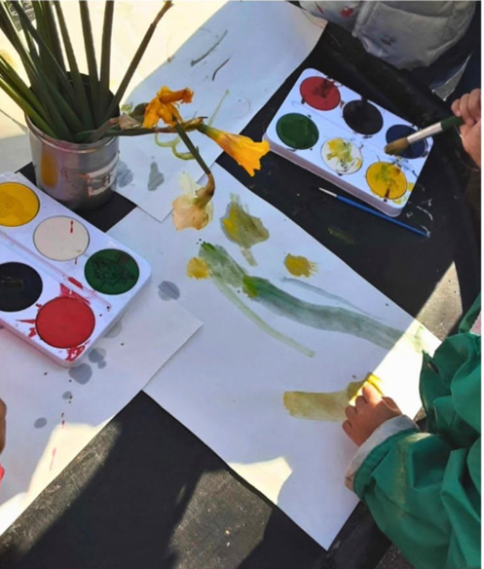
At Gracelands Nursery School, every child is encouraged to become an active, curious learner within an environment that celebrates creativity, independence and joyful exploration. Throughout the year, Governors have seen children fully engaged in carefully planned experiences that build upon their interests while developing communication, early mathematics, literacy and problem-solving through meaningful play. Rich indoor and outdoor environments provide endless opportunities for imaginative thinking, with practitioners skilfully extending children's ideas through thoughtful questioning and sensitive interactions. The result is a nursery where children are confident to take risks, persevere with challenges and celebrate their own achievements.
One of Gracelands' greatest strengths is the consistency of its curriculum and the expertise of its staff team. Practitioners work collaboratively to continually review and refine learning environments so that they remain responsive to children's interests and developmental needs. Governors have been particularly impressed by the calm, purposeful atmosphere throughout the nursery, where high expectations are matched by warmth, kindness and genuine respect for every child. Whether immersed in imaginative role play, creating collaboratively, exploring outdoors or sharing stories together, children experience a curriculum that inspires confidence, nurtures curiosity and enables every child to flourish.

Highfield Nursery School

Every Conversation Builds Confidence
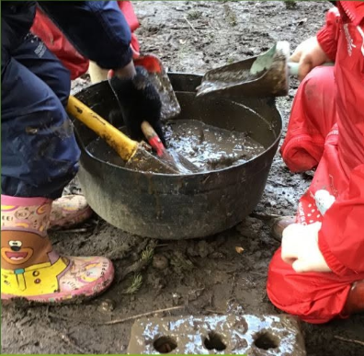
At Highfield Nursery School, communication lies at the heart of children's learning. Throughout the year, the staff team has continued to strengthen children's language, confidence and emotional wellbeing through a curriculum that places relationships, conversation and purposeful play at its centre.
Governors have seen children enthusiastically sharing ideas, asking questions and developing new vocabulary in carefully planned learning environments where adults skilfully extend thinking through meaningful interactions.
Targeted approaches, including WellComm assessments and language interventions, ensure that children receive the right support at the right time, enabling every child to develop the communication skills needed to thrive both socially and academically.
The nursery's inclusive ethos is reflected in the thoughtful way staff respond to every child's individual strengths and needs. Whether engaging in small-group learning, exploring high-quality storybooks, investigating mathematical concepts through play or developing emotional resilience through nurturing relationships, children are encouraged to become confident, independent learners who enjoy challenge and discovery. Governors have been particularly impressed by the warm, purposeful atmosphere throughout the nursery and the dedication of staff in ensuring that every child feels valued, listened to and successful.
Highfield continues to demonstrate how exceptional early communication provides the strongest possible foundation for lifelong learning and we are particularly proud of the exceptional outdoor learning opportunities at our Dyson Gardens site and of the newly under two’s provision where our youngest children can flourish!

Jakeman Nursery School

A Place Where Every Child Belongs
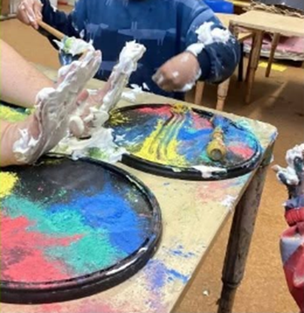
Jakeman Nursery School is a place where inclusion is lived every day through warm relationships, thoughtful environments and a deep understanding of every child's individual needs.
Governors visiting the school this year were struck by the calm, purposeful atmosphere and by the confidence with which children explored both the indoor and outdoor learning environments. Carefully designed spaces encourage curiosity, imagination and independence, while skilled practitioners sensitively extend children's learning through conversation, play and shared discovery.
The school's commitment to ensuring every child experiences success is reflected in the way children confidently make choices, persevere with challenges and develop strong friendships within a caring and supportive community.
A particular strength of Jakeman continues to be its highly inclusive approach to supporting children with additional needs. The thoughtfully developed Oak Room provides specialist support while enabling children to remain fully involved in the wider life of the nursery, ensuring that inclusion is experienced rather than simply planned. Throughout the year, staff have continued to refine learning environments and work closely with families to provide personalised support that helps every child thrive.
Governors were especially impressed by the quality of adult-child interactions and the confidence, independence and joy displayed by children across the nursery. Jakeman continues to demonstrate that when children feel safe, respected and understood, they develop the resilience and curiosity that will support them throughout their education.

Lillian de Lissa Nursery School

Transforming Spaces, Inspiring Possibilities
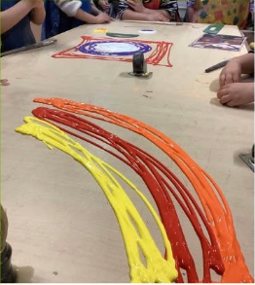
This year has been one of exciting transformation at Lillian de Lissa Nursery School, with significant developments to both the curriculum and learning environments ensuring that every child can explore, create and thrive.
Governors were particularly impressed by the carefully redesigned provision for two-year-olds, which now provides a calm, welcoming space where the youngest children develop secure relationships and growing independence.
Across the nursery, new creative studios, music and movement areas, sensory spaces and enhanced provision have created even greater opportunities for children to investigate, experiment and follow their own interests. Outdoor learning has also been enriched through the introduction of new growing areas, imaginative play spaces and natural resources, with children responding with visible excitement, curiosity and awe as they explored the transformed environments for the first time.
These developments reflect the school's unwavering commitment to providing an ambitious, inclusive curriculum for every child. This commitment has been recognised externally through the school's recent Ofsted inspection, which praised the warm relationships between adults and children, the carefully designed curriculum and the high expectations staff have for every learner. Working closely with families and specialist professionals, the team continues to ensure that children with SEND are fully included within nursery life, supported by environments that encourage independence, creativity and communication. Governors are immensely proud of the school's continuing journey of improvement and of a staff team whose passion, imagination and commitment ensure that every child leaves Lillian de Lissa with confidence, curiosity and a love of learning.

Newtown Nursery School

Creating Environments Where Every Child Can Thrive
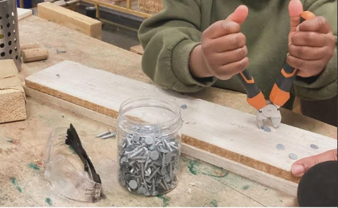
This year has been one of remarkable development at Newtown Nursery School, with significant investment in learning environments, curriculum and provision for the youngest children.
Governors were delighted to see the newly established Baby Room, redesigned to create a warm, homely atmosphere where babies can build secure relationships through responsive care, sensory exploration and language-rich experiences.
Across the nursery, carefully connected spaces allow children to move confidently between the Baby Room, two-year-old provision, nurture areas and the wider learning environment, encouraging independence while ensuring that every child feels safe and supported. The transformation of the studio, enhanced SEND spaces and creative learning environments has created inspiring opportunities for exploration, investigation and imaginative play, with children responding with obvious excitement and curiosity as they discover new experiences each day.
Communication and relationships remain at the heart of Newtown's curriculum. Protected learning time, WellComm interventions and carefully planned language groups enable staff to know every child exceptionally well and provide learning that reflects individual interests and stages of development. An Artist in Residence has worked alongside staff and children to transform the creative studio, introducing loose parts, sensory materials and inspiration from the work of Andy Goldsworthy, while weekly nature sessions, woodwork and open-ended play continue to develop children's creativity, resilience and problem-solving skills. Governors have also recognised the strength of the school's inclusive practice, where high-quality nurture provision, enhanced SEND support and close partnerships with families ensure that every child is encouraged to participate, belong and flourish.

Shenley Fields Nursery School

Learning Through Rights, Relationships and Nature
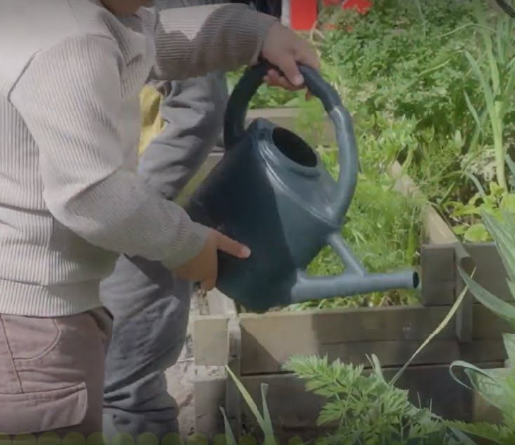
At Shenley Fields Nursery School, children are encouraged to become confident, compassionate citizens from their very earliest years.
As one of the UK's first Gold Rights Respecting Early Years settings, children's rights are woven through every aspect of nursery life, helping children develop empathy, responsibility and a strong sense of belonging.
This year, the children's Rights Steering Group has explored how they can support others through projects linked to the Lighthouse Project and local food banks, while a Froebel-inspired curriculum has continued to nurture curiosity through play, storytelling, music, creativity and outdoor learning. From creating artwork in the vibrant art studio to growing vegetables in the allotment, cooking with home-grown produce and exploring local parks through Forest School, children experience a curriculum that connects them with their community and the natural world. Family trips to Dudley Zoo, visits from firefighters, nurses and police officers, and opportunities to learn alongside parents have further enriched children's experiences beyond the nursery gates.
Inclusion is at the heart of everything Shenley Fields does. Staff are highly skilled in recognising and responding to every child's individual strengths and needs, supported by exceptional SEND practice, strong partnerships with families and close collaboration with health and specialist services. This year the school has continued to strengthen communication through daily story experiences, Makaton, My Happy Mind, early reading workshops and family engagement activities, while plans to extend the highly successful Sunshine provision reflect the school's continuing ambition to meet the needs of its community. Governors have been particularly impressed by the warmth of relationships, the outstanding quality of the learning environments and the evident pride children take in caring for one another, their nursery and the world around them. Shenley Fields continues to demonstrate that inclusion is about far more than access—it is about ensuring every child feels seen, heard, valued and inspired to flourish.

St Thomas Centre Nursery School

A Community Reimagined Through Creativity and Care
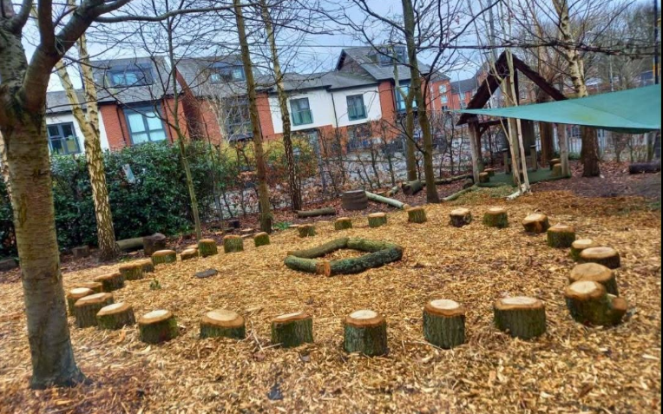
This year has marked an exciting new chapter for St Thomas Centre Nursery School. Under strong and purposeful leadership, the nursery has continued its remarkable journey of transformation, creating an inspiring learning environment where every child is encouraged to explore, create and belong. Following further developments of its learning environments within the building, staff have developed a curriculum shaped by children's interests, family experiences and current early years research. Beautifully designed spaces, including the Visual Art Studio, Construction Studio, nurture areas and thoughtfully planned outdoor environments featuring an allotment, life-size beach, lazy river and story circle, provide children with rich opportunities to investigate, imagine and solve problems through play. Serving a richly diverse community, the nursery places particular importance on ensuring that every child feels welcomed, represented and valued from their very first day.
Relationships remain the foundation of everything the nursery does. Staff are highly reflective practitioners who know their children exceptionally well, using careful observation and professional dialogue to shape learning around each child's interests and developmental needs. Governors have been particularly impressed by the calm, purposeful atmosphere throughout the nursery, the quality of interactions between adults and children, and the imaginative environments that encourage curiosity and independence. Families are recognised as essential partners in children's learning, while the nursery's commitment to wellbeing, inclusion and emotional development continues to shape the next phase of its curriculum. St Thomas Centre Nursery School demonstrates how ambitious leadership, creative thinking and a deep understanding of children can transform not only a learning environment, but the opportunities available to every child and family it serves.

Looking Ahead to 2026–27

Building on Strong Foundations
As we look ahead to the coming year, we do so with confidence, optimism and a clear sense of purpose. The achievements celebrated throughout this report reflect the dedication of our staff, leaders, Governors and families, but they also remind us that early childhood education continues to evolve. As a Federation, we remain committed to ensuring that our schools are at the forefront of research-informed practice while responding positively to the changing national and local landscape for young children and their families.
Across Birmingham, the ambitions of Best Start in Life (Best Start Brum) reinforce what we have always believed—that improving outcomes for children depends upon strong partnerships between education, health, families and communities. As maintained nursery schools, we are proud to play a leading role within this vision, working collaboratively with partners to ensure that every child can benefit from high-quality early education, timely support and smooth pathways through the early years. Our schools will continue to contribute to Birmingham's shared ambition of improving school readiness and reducing inequalities by providing exceptional learning experiences from birth to five.
We also welcome the continuing national focus on creating a more inclusive education system. The Government's reforms following the SEND and Alternative Provision Improvement Plan place greater emphasis on earlier identification, inclusive mainstream provision and closer partnership with families. These principles have long been embedded within our Federation. Over the coming year, we will continue to strengthen our inclusive practice by investing in staff expertise, developing enabling environments and working closely with health, education and specialist partners to ensure that every child receives the support they need to thrive alongside their peers.
Alongside these developments, we will continue to respond to the significant expansion of funded early education and childcare for younger children. As more families become eligible for funded places from the age of nine months, our schools will continue to develop high-quality provision for babies and toddlers, recognising that secure relationships, play and communication in the earliest years provide the strongest foundations for lifelong learning.
Professional learning and collaboration will remain one of the Federation's greatest strengths. Through our shared leadership, curriculum development, SEND networks and practitioner collaboration, we will continue to learn from one another, drawing upon the latest evidence in early childhood education to continually improve the experiences we offer children. We will also continue to champion outdoor learning, creativity, communication and language, children's rights and family engagement, ensuring that our curriculum reflects both the latest research and the unique communities we serve.
As Governors, we remain committed to providing both support and constructive challenge as the Federation continues its journey. We will continue to celebrate success, listen carefully to children, families and staff, and ensure that every decision we make is guided by one simple question: "Will this improve outcomes for our children?"
The future of early childhood education will undoubtedly continue to change, but our purpose remains constant. We want every child who attends one of our schools to leave as a confident communicator, an enthusiastic learner and a resilient young citizen, ready to embrace the opportunities that lie ahead.
Because when children experience belonging, inclusion and high-quality early education, they don't simply become ready for school—they become ready for life.

Our Priorities for 2026–27
Over the coming year, Governors will continue to support the Federation in delivering six shared priorities:
Deliver Birmingham's ‘Best Start Brum’ vision, ensuring every child has the strongest possible start through high-quality early education, integrated support and strong partnerships between families and services.
Champion inclusive practice, building on national SEND reforms by strengthening early identification, intervention and inclusive provision so that every child can participate, belong and succeed.
Develop exceptional provision from birth to five, responding to the expansion of funded childcare while maintaining the highest standards of care, education and family support.
Invest in our workforce, supporting research-informed professional development, leadership and collaboration across the Federation.
Create inspiring environments, indoors and outdoors, that nurture curiosity, creativity, wellbeing and a lifelong love of learning.
Further strengthen collaboration across our nine schools, sharing expertise and innovation to improve outcomes for every child across Birmingham.

"Our ambition is not simply to prepare children for school, but to give every child the confidence, curiosity and resilience to flourish throughout their lives."

Acknowledgements

The Governing Board would like to express its sincere thanks to everyone who has contributed to another successful year across the Birmingham Federation of Maintained Nursery Schools.
First and foremost, we thank the wonderful children in our care, whose curiosity, creativity and enthusiasm for learning inspire everything we do. We are equally grateful to our parents, carers and families for their continued trust, encouragement and partnership, recognising the vital role they play as children's first and most important educators.
Our thanks also go to every member of staff across the Federation. Your professionalism, compassion and unwavering commitment ensure that our schools remain welcoming, inclusive places where every child can thrive. We are grateful to our Senior leadership team, and fellow Governors for their vision, dedication and service, and to our many education, health and community partners whose collaboration helps us provide the very best start in life for Birmingham's youngest children.
As Governors, we are incredibly proud of what has been achieved across our Federation this year. We look forward to continuing to work alongside our children, families, staff and partners to continue demonstrating what can be achieved when schools, families and communities work in partnership for children.

